Polyphasic taxonomy
Polyphasic taxonomy is the consensus approach to bacterial taxonomy which integrates several generally accepted ideas for the classification of bacteria. It takes into account all available phenotypic and genotypic data and integrates them in a consensus type of classification. The term “polyphasic taxonomy” was introduced by Colwell (1970).
The minimal requirements for obtaining useful polyphasic data are:
- a preliminary screening for groups of similar strains
- determination of the phylogenetic placement of these groups
- measurement of the relationships between the groups and their closest neighbours,
- Collection of various descriptive data, preferentially on different aspects of the cell.
Conventional, molecular and recent approaches
Classification of microorganisms was earlier done on the basis of traditional microbiological methods (morphological, physiological and biochemical). However, these techniques are time consuming as well as dependent upon many environmental factors. Therefore, the advanced techniques like sequence based, gel based and protein based systems have become advantageous due to their fast reactions, high specificity and less chance of error.
Hence, the methods now employed for bacterial systematics include, the complete 16S rRNA gene sequencing and its comparative analysis by phylogenetic trees, DNA-DNA hybridization studies with related organisms, analyses of molecular markers and signature pattern(s), biochemical assays, physiological and morphological tests.
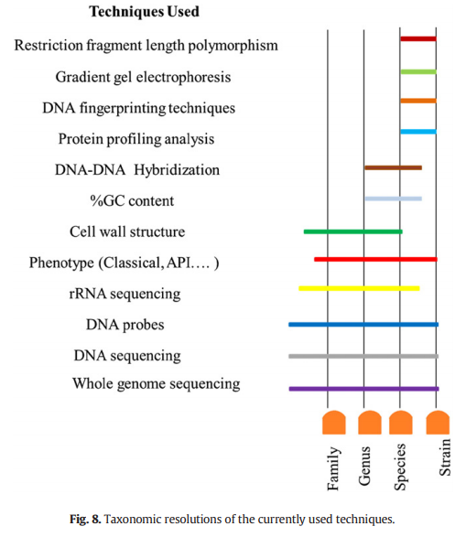
Evolutionary chronometers
Evolutionary distance is the difference in nucleotide or amino acid sequence of functionally homologous macromolecules. There are four criteria for the correct molecule to be chosen to measure evolutionary distance by sequencing. The criteria are the molecular chronometer should be universally distributed across the group, the molecule must be functionally homologous in each organism, it must also have regions of sequence conservation for aligning the sequence for study and the sequence of the molecule chosen should reflect evolutionary change in the organism as a whole. An evolutionary chronometer (or E_{D}) is a nucleotide or amino acid sequence that is similar between two organisms and can be used to measure their evolutionary separation. Evolutionary distance (or how many ancestors ago the two species diverge) is proportional to how many differences there are between the nucleotide or amino acid sequences. Thus, an evolutionary chronometer (also denoted E_{D}) essentially represents the number of changes between two sequences. DNA segments encoding ribosomes, ATPases and DNA Polymerases are all good evolutionary chronometers because they are universally conserved for the most part.
The sequences of nucleic acids and proteins change with time and are considered to be molecular chronometers. This concept was first suggested by Zuckerkandl and Pauling (1965).
rRNA gene sequencing
There are several ways to sequence rRNA. Ribosomal RNAs can be characterized in terms of partial sequences by the oligonucleotide cataloging method as follows.
- Purified, radioactive 16S rRNA is treated with the enzyme T1 ribonuclease, which cleaves it into fragments.
- The fragments are separated, and all fragments composed of at least six nucleotides are sequenced.
- The sequences of corresponding 16S rRNA fragments from different procaryotes are then aligned and compared using a computer, and association coefficients (Sab values) are calculated.
Complete rRNAs now are sequenced using procedures like the following.
- First, RNA is isolated and purified.
- Then, reverse transcriptase is used to make complementary DNA (cDNA) using primers that are complementary to conserved rRNA sequences.
- Next, the polymerase chain reaction amplifies the cDNA.
- Finally, the cDNA is sequenced and the rRNA sequence deduced from the results.
Advantages
- The rRNAs are almost ideal for studies of microbial evolution and relatedness since they are essential to a critical organelle found in all microorganisms.
- Their functional role is the same in all ribosomes.
- Their structure changes very slowly with time, presumably because of their constant and critical role.
- Because rRNA contains variable and stable sequences, both closely related and very distantly related microorganisms can be compared. This is an important advantage as distantly related organisms can be studied only using sequences that change little with time.
Applications
- 16S rRNA gene sequencing has been established as the “gold standard” for identiﬁcation and taxonomic classiﬁcation of bacterial species.
- Comparison of the bacterial 16S rRNA sequence has been emerged as a valuable genetic technique and can lead to the recognition of novel pathogens such as Mycobacterium species.
- The hyper variable regions of 16S rRNA gene sequences provide species-specific signature sequences useful for bacterial identification.
- In medical microbiology, 16S rRNA sequencing serves as a rapid and cheap alternative to phenotypic methods of bacterial identification.
- It is also capable of reclassifying bacteria into completely new species, or even genera.
- The sequencing techniques can be used to describe new species that have never been successfully cultured in laboratories.

